**Task-3**

Q: Create a VM and choose resources such as V-net, NSG, NIC, Subnet which are created before hand, then take a snapshot of data disk and attach it to the newly created VM, also create a Custom image of the VM which is provisioned.

Create a Resource Group: Here Ex:-SaiRG

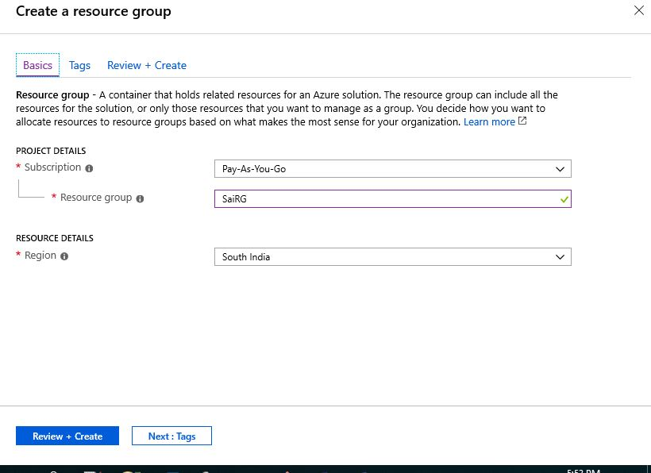

Create a V-net in the same Resource Group which is created.

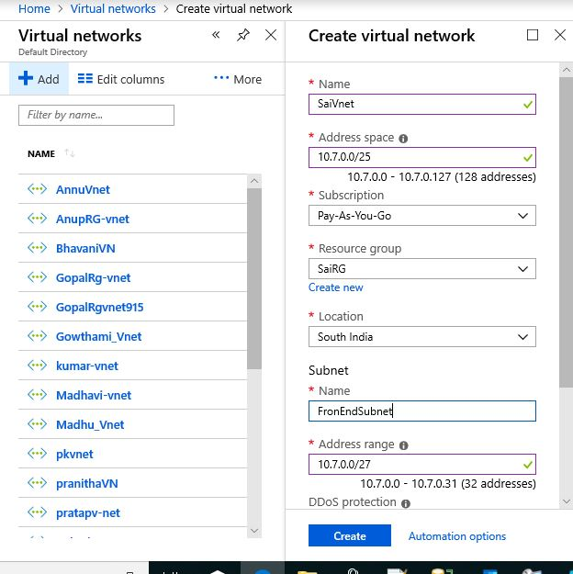

Create an Availability set with 2 fault domains and 5 Update domains.

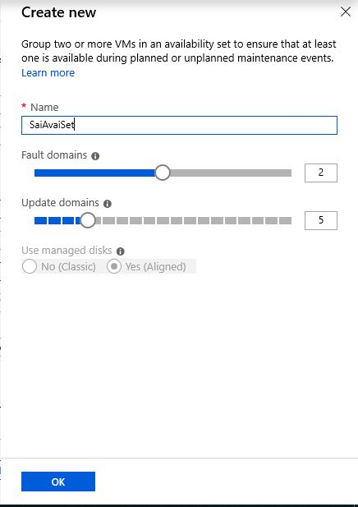

Create a Network security group

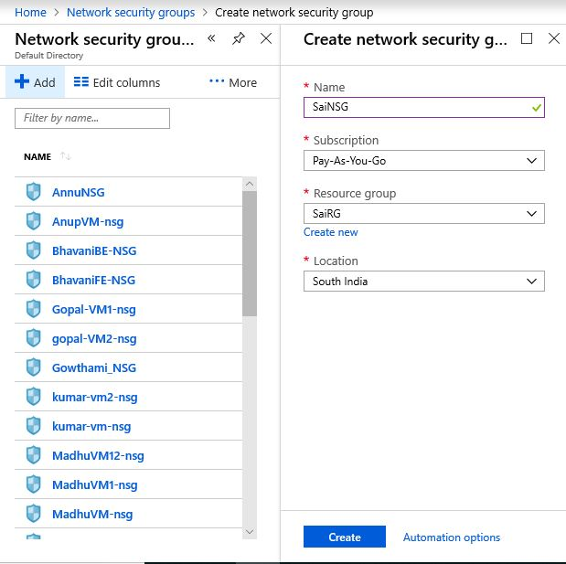

Create a NIC (Network interface Card)

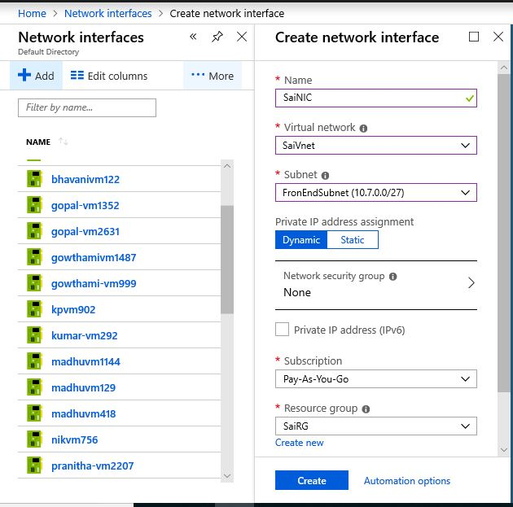

Create a VM using all the above created resources.

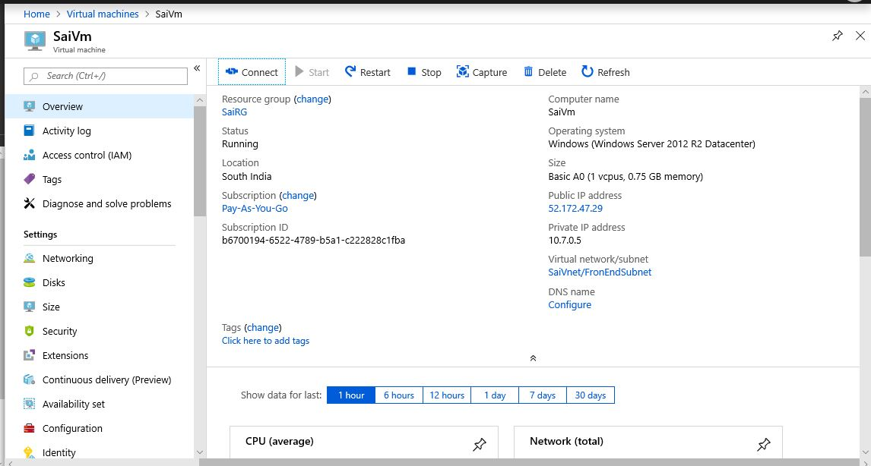

Create a Data Disk while creating a VM in the Disks section.

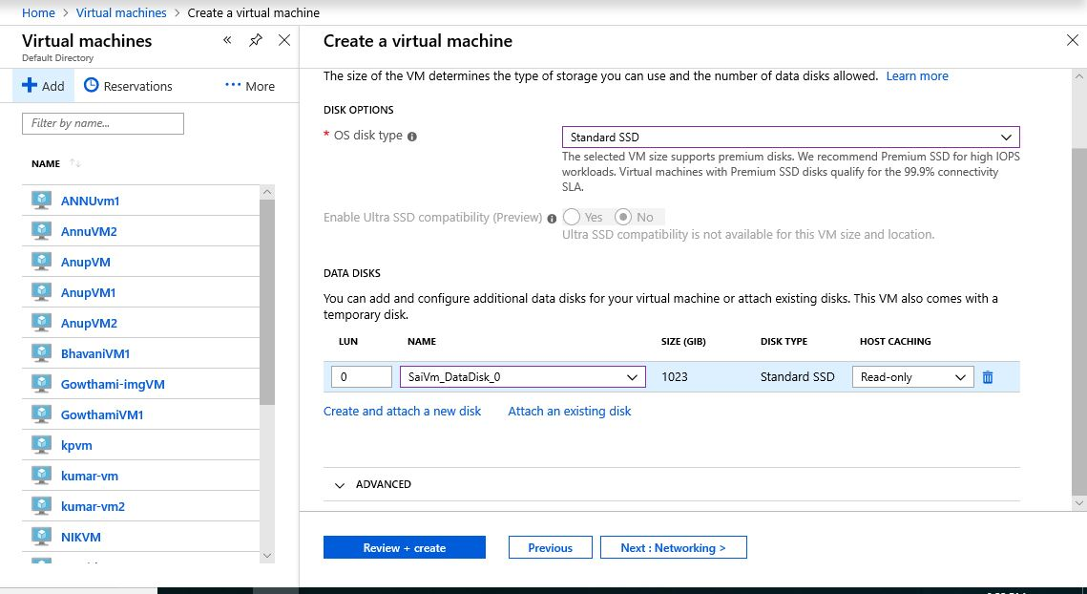

VM overview which is provisioned by following above steps



Now go to VM section and choose Disks in the left pane and create a Snapshot of DataDisk

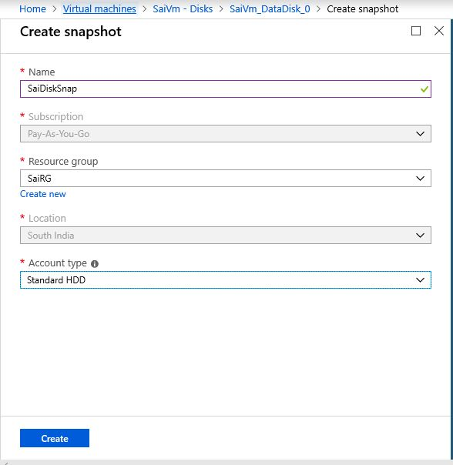

Now create a new VM and attach Data Disk to it which is in Snapshots.



Creating a Custom image of the VM which is provisioned. First connect to VM through RDP and do a Sysprep.

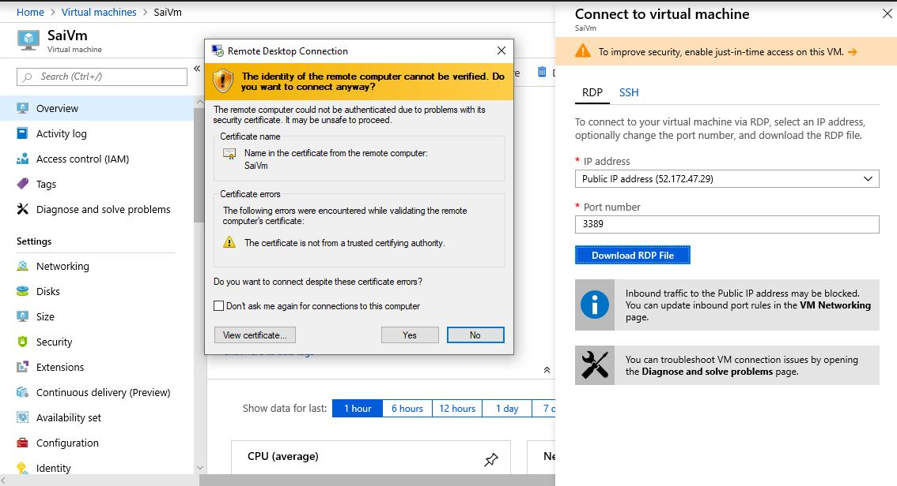

Now VM is Accessible.

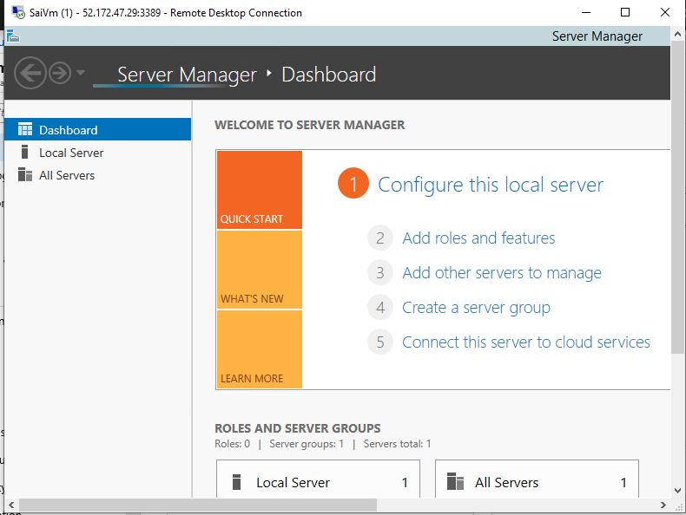

Doing a SysPrep to the VM by entering (Windows+R)

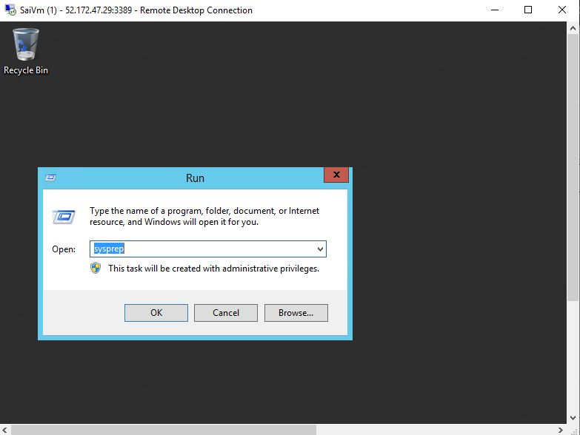

Choose Generalize and select shutdown to make image available. This will terminate session after prep.

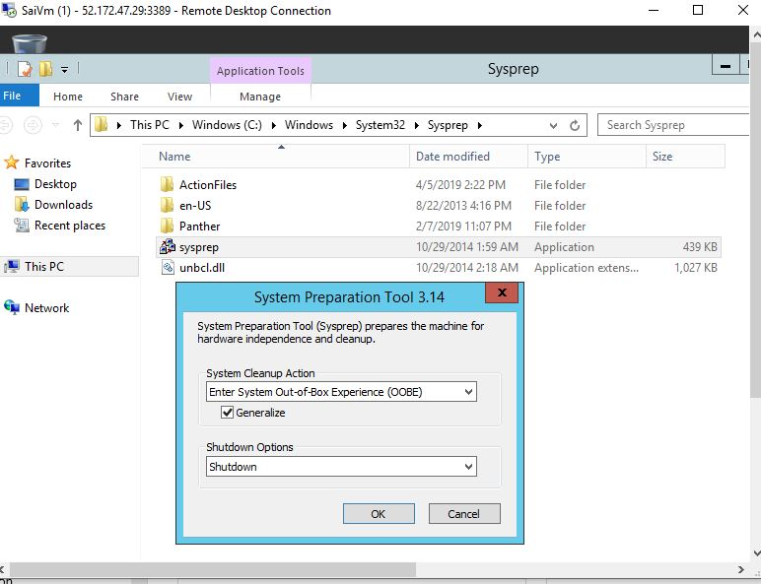

Sysprep in Progress…………….

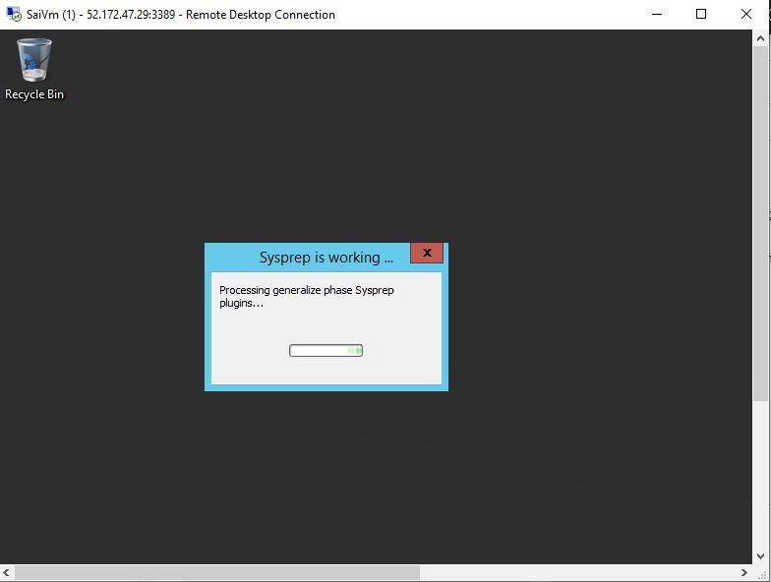

Now go to portal and Capture the Image later we can use it as base.

